**17 MCM abstract template (Times** **New Roman, 15pt, bold)**

Name Surnamea, Name Surnameb, … (Times New Roman, 12 pt)

*aInstitution, (City), Country (Times New Roman, 11 pt, italic)*

*bInstitution, (City), Country (Times New Roman, 11 pt, italic)*

*Contact email:* [*corresponding.author@email.si*](mailto:corresponding.author@email.si) *(email of the corresponding author)*

**Instruction for the authors:** the corresponding author should be underlined and will be the contact person for the organizers. At least one of the authors needs to be registered for 17th Multinational Conference on Microscopy (17MCM). The corresponding author is responsible for ensuring that all co-authors agree with the content of the submitted abstract.

**The abstract must not be more than two A4** (21 cm x 29,7 cm) **pages long. Only Microsoft Word files (.docx and .doc) are supported. The text of the abstract should also be pasted as text only in the corresponding field of abstract submission form.**

Additional requirements:

* the document should be written in Times New Roman font with font size 11.
* one-line spacing (Spacing before and after: 0 pt, Line spacing: single);
* the margins should be: 2 cm on the top and bottom, 2.5 cm on the left and right, justified.

The abstract can contain max. **two figures** (the figures can contain multiple images, graphs, tables, schemes …- as long as the total length does not exceed two pages).

The header and footer should not be changed.

To submit your paper, please use the conference participant portal: <https://www.conftool.com/17mcm-2025>

The abstract must be submitted as a single file.

The structure of the abstract should be the following:

* **Introduction:** the main purpose of the research or the presentation.
* **Methods:** instruments and methods used in the research, sample characteristics, sample preparation methods and methods used to analyse the data.
* **Results:** description of the main results
* **Discussion and conclusions:** the main findings, importance of the research, future plans.
* **Acknowledgments,** if appropriate**.**

The references are marked with square brackets, with the sequential reference number – [1] and referred at the end of the document.

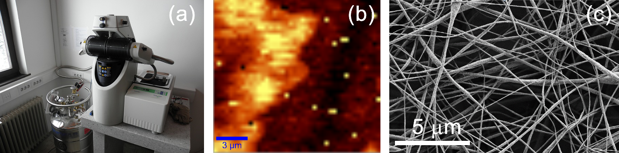

Figure 1: Figure description. Detailed description of figure (a), detailed description of figure (b), detailed description of figure (c). (Times New Roman, font size 11)

References:

1. J. Novak, B. Poljak, *Acta Chem. Slov.* **2018**, *54*, 11-15. (Times New Roman, 11 pt)

2. J. Novak, B. Poljak, *Nature Slov.* **2022**, 48, 25-29. (Times New Roman, 11 pt)